Documentation of the NavigationMenu design
General information:
Background color: █ 234E4D
Text color: ☐ FFFFFF
Main font: Open Sans

View on the screen:
- The navigation menu opens in front of the screen.
- Menu opens from the icon on the left of the navigation bar 
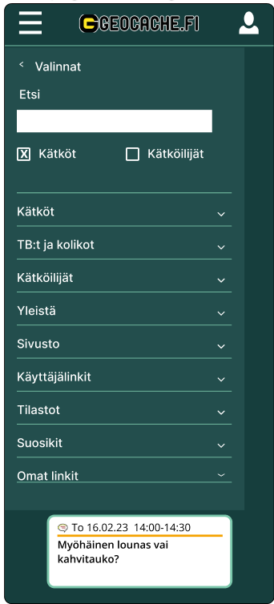

Search bar with filters:
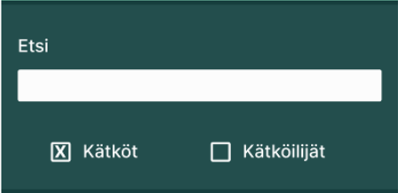
Background color: █ 234E4D
Text color: ☐
Text font: Open Sans
- Search page with results will open when the user complete first search from the main menu.
- Search will start by pressing the "enter" key on keyboard.
- There are two search attributes “Kätköt” ja “Kätköilijät” (Caches and Cachers) which you can choose from which areas to search from, if neither is selected, both areas will be included.
- When you start typing in the search field, predictive text input suggests possible search words.

Main Menu:
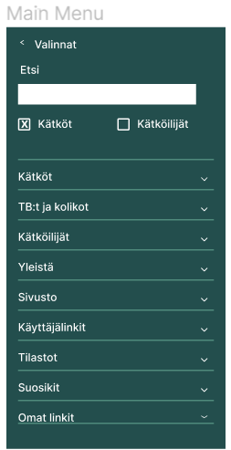
Below pictures of each menu opened:
Menu Kätköt:
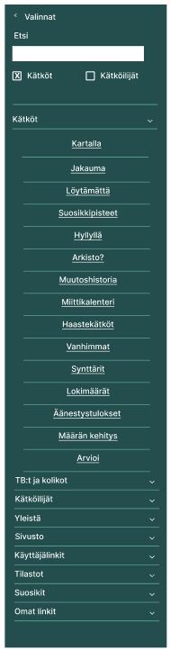
Menu TB:t ja kolikot:
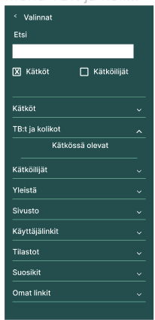
Menu Kätköilijät:
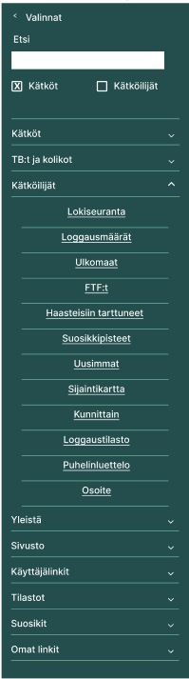

Menu Yleistä:
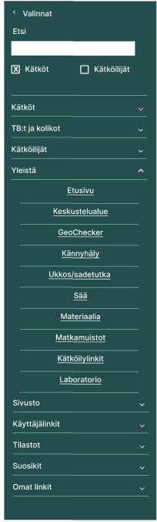

Menu Sivusto:
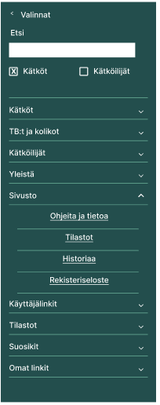
Menu Käyttäjälinkit:
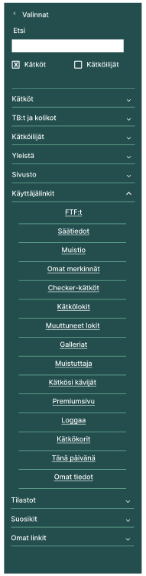

Menu Tilastot:
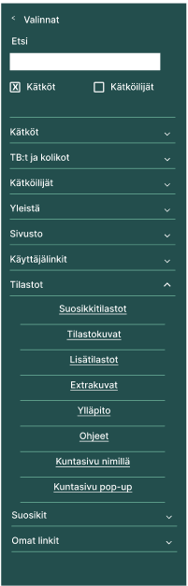
Menu Suosikit:
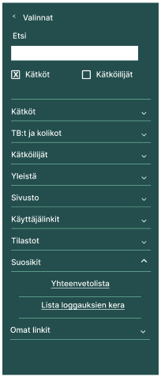
Menu Omat linkit:
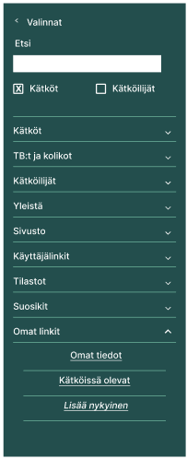
Menu All:

